**Customizable Checkout Instructions**

Please take the time to read through the instructions before beginning the checkout customization. This will ensure that the files will be correctly edited and allow for a smooth upload to get the checkout functioning.

# What you received:

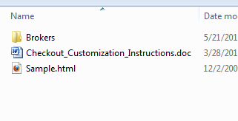

Visual Aid Sample file

Files to be altered and sent

## Sample.html File

1. Open using a code editor (Visual Studio, etc)
2. There are sections marked for editing and non-editing Identify the portions that need changes made. Changes made to the Do Not Edit portions will render the checkout unusable.

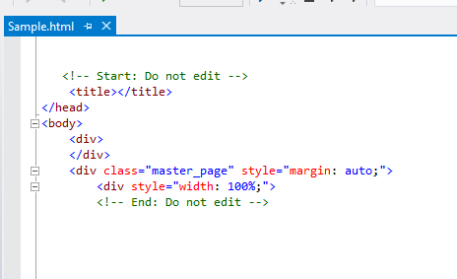

Non-Editing Area

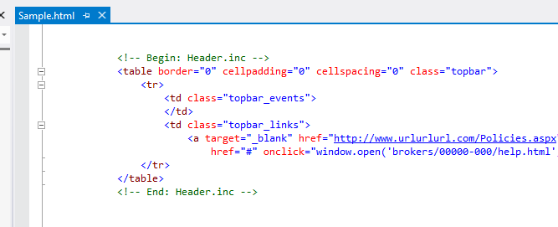

Change the generic code for Site specific information

File to be edited in the Includes folder of the Broker files

1. Make changes to the sample code as needed to see a visual of what the checkout will look like once uploaded.

Note: **This is not the checkout files that are uploaded and this file is for viewing purposes only**

1. Brokers Folder
2. Open the folder “Broker Folder” and re-name the folder inside from 00000-000 to the correct broker ID number and site number. The broker ID is 5 digits and the site is 3 digits. The proceeding zeroes must be included to keep this true.

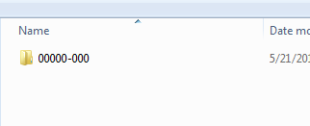

Change to the BID and site number

1. Open the renamed folder to apply the changes made to the Sample.html file to the checkout files that are needed to create the custom checkout

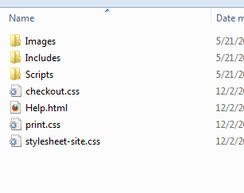

1. Add custom logos and icons to the Images folder- Ex- “logobar_logo.jpg” should be the image for the site logo.
2. Open the Includes folder and change the files with the corresponding code from the Sample.html folder
3. All instances of “00000-000” should be replaced with the correct broker ID and site number in every Include file

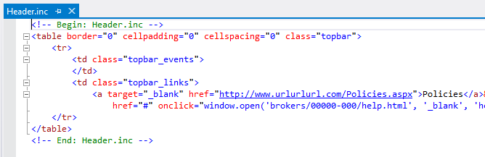

Replace with the correct url for the site

All instances need to be renamed correctly in all folders

1. Wherever it says “broker_name_” replace with the company name

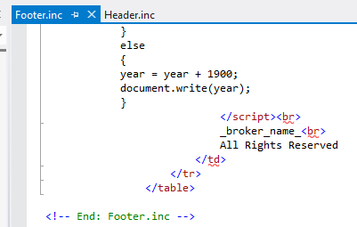

Change to reflect the company name

1. Change all instances of “.aspx” file extensions to the correct type of file you are using (.html, .php, .asp) If they are .aspx, no changes need to be made

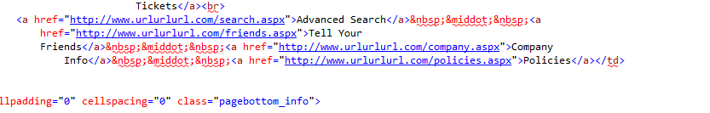

Be sure file extensions match

1. In the Help.html file, change the site name and _broker_email_ to reflect the correct company name and email address

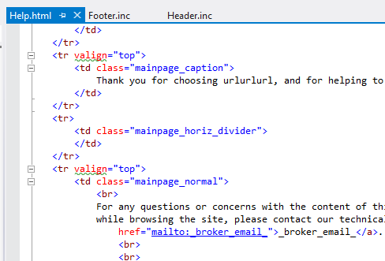

Link to correct email address and the email name

Change to company name

## Important Changes:

1. URL Addresses must be fully qualified

Ex: <a href=”<http://www.yourdomainname.com/lasvegas.aspx>”> is correct

<a href=”lasvegas.aspx”> is incorrect

1. Linking Includes files to Images folder must include the broker ID number and site number:

Ex: <img src=”brokers/01504-001/images/logo.jpg”/> is correct

<img src=”brokers/00000-000/images/logo.jpg”/> is incorrect

<img src=”images/logo.jpg”/> is incorrect

1. Linking to external stylesheets should follow proper xhtml guidelines:

Ex: <link rel=”stylesheet” type=”text/css” href=”brokers/01504-001/style.css” /> is correct

<link rel=”stylesheet” type=”text/css” href=”brokers/00000-000/style.css” /> is incorrect

<link rel=”stylesheet” type=”text/css” href=<http://www.url.com/style.css> /> is incorrect

## Mistakes to Avoid:

1. <form> tags. The checkout will **not** operate with the use of any <form></form> tags in the page.
2. Do **Not** link to outside images/files/stylesheets as it will create an unsecure connection in your checkout
3. Do **Not** add tracking codes to any part of the checkout. All tracking codes should be added via a support ticket or emailing [websites@ticketnetwork.com](mailto:websites@ticketnetwork.com)

# Breakdown of Includes Files:

### Boxend.inc

This contains the bottom of the box that is used in the main checkout area.

### Boxstart.inc

This contains the top of the box that is used in the main checkout area.

### Footer.inc

This contains links, copyright date, and company info at the bottom of the page.

### Header.inc

Has links to your policies and help.html (popup) file.

### Horizontaldivider.inc

Contains the code for the divider (most leave this as-is).

### Htmlhead.inc

This is used for any custom stylesheet references.

### Logobar.inc

This includes your logo, menu, and search area.

### Scripts.inc

This is used for any scripts you may have. You may put your .js files in the scripts folder. Reference your scripts as follows: “brokers/00000-000/Scripts/YourScript.

### Sidebarleft.inc

This contains the purchase notes as well as room for other custom images or text.

### SideBarRight.inc

Optional: area to the right of the main checkout. You may add any additional information to this section to appear on the sidebar right of the checkout.

# Stylesheets Important Notes:

1. The Checkout.css, print.css, and stylesheet-site.css will be automatically referenced in the generic code so you will not have to include them in the HtmlHead.inc file.
2. Print.css file will not change for most people, it simply needs to exist in the folder
3. The Stylesheet-site.css controls the other features which are explained in the css comments

# Completion:

1. Please check all Includes files for proper labeling of file names. It is a 5 digit- 3 digit number. The BID is Always 5 digits and the Site number is Always 3 digits.
2. The Sample.Html file is not used in any way for upload so all changes must be made in the Brokers folder
3. Once the files are reviewed and complete, please send the zip file to be uploaded for the customized checkout